PI: Anan Nellan

Project: CAR-T in Ependymoma

Biostatistician: Kristen Miller

**Statistical Methods**

*Figure 1:* Box plots were produced for histology count by treatment group for each experiment. Comparisons by treatment group were performed using Wilcoxon rank sum test.

*Figure 2*: Time to death in days was reported using Kaplan Meier (KM) curves stratified by treatment group for each experiment. Because there was no censoring, time to death was compared between treatment groups using Wilcoxon rank sum tests. In the case of three groups, a Krukall-wallis test was used.

*Figures 3 and 4:* Linear mixed modeling was used to analyze tumor volume and luminescence over time. In Figure 3, tumor volume was the outcome and the predictors were days (categorical), treatment group, and days*treatment group interaction. Overall F-tests were used to determine if the interaction term was significant. If significant, contrast statements were used to calculate comparisons of interest: (1) an overall difference in volume at each timepoint between groups, and (2) whether the change from first to last time point was different between groups. In Figure 4, the same modeling procedure was followed, except with the outcome of luminescence. Due to the larger number of timepoints, we tested for (1) an overall difference in volume at baseline, mid-experiment, and the last time point, and (3) whether the change from first to last time point was different between groups. Adjustment for multiple comparisons was done using Bonferonni adjustment based on the number of contrasts used for each experiment.

Figure 1: Histology

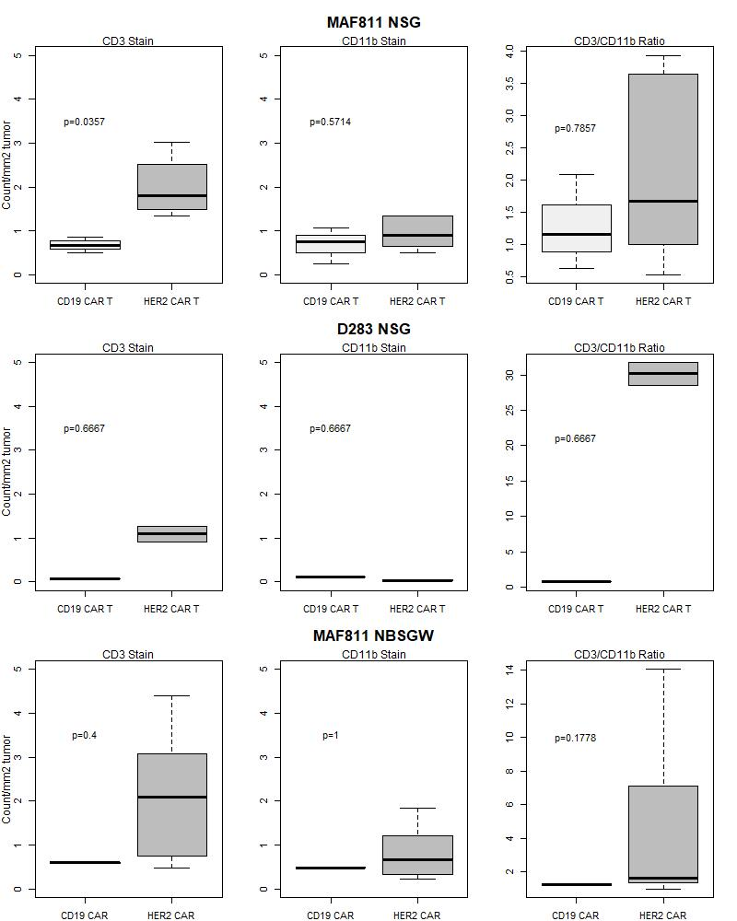

P<0.05 indicates a significant difference in counts between treatment groups.

Figure 2: Survival Curves

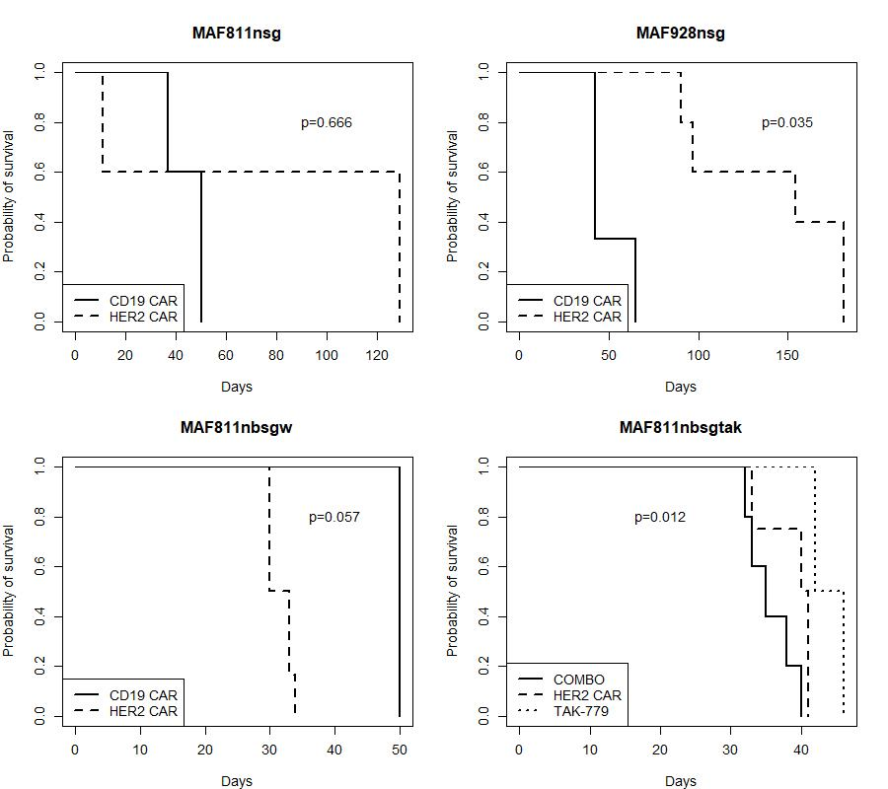

In the MAF811 NSG TAK experiment, there was a difference in survival between the three groups, overall (p=0.012). TAK-779 had significantly longer days to death compared to COMBO (p=0.005).

Figure 3: Tumor Volume

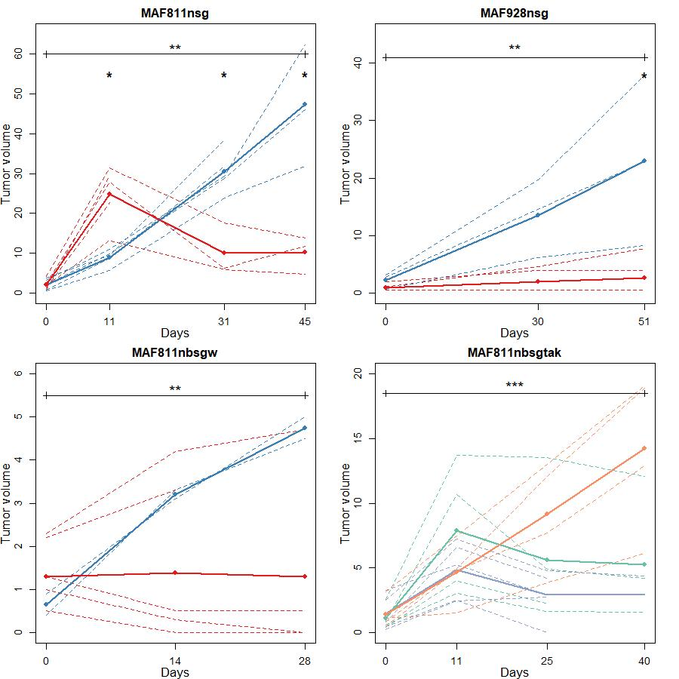

LEGEND (A, B, C): Red = HER2 CAR, Blue = CD19 CAR. (D): Blue = COMBO, Green = HER2 CAR, Yellow = TAK 779. ALL: dotted lines = individual mice, solid line = average line (from modeling)

* indicates a significant difference between the two groups at that time point. For example, In MAF811nsg, there was a significant difference in volume at day 11, day 31, and day 45 between the two groups. NOTE: for MAF811nbsgtak, tests at each time point were not performed.

** indicates that the change from pre-treatment to the last day of the experiment was different between the two groups. For example, in MAG811nbsgw, mice treated with CD19 CAR had significantly more tumor growth compared to those treated with HER2 CAR.

*** indicates that the change over time was significantly different between: HER2 CAR vs. TAK-799 and between COMBO vs. TAK-779. Both HER2 CAR and COMBO had significantly less tumor growth compared to TAK 779. There was no difference in the change over time between COMBO and HER2 CAR.

Figure 4: Luminescence

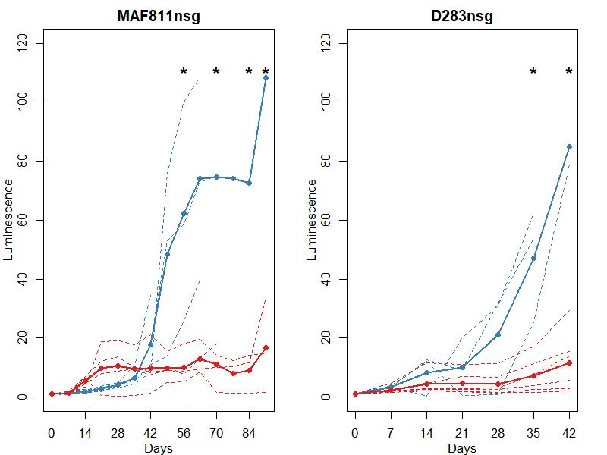

LEGEND: Red = HER2 CAR, Blue = CD19 CAR

dotted lines = individual mice, solid line = average line (from modeling)

* indicates a significant difference between the two groups at that time point.